[Skip to content](https://www.safaribooksonline.com/library/view/software-test-engineering/9780137036455/ch03.html" \l "container)

* [*Safari*](https://www.safaribooksonline.com/home/)
* [Recommended](https://www.safaribooksonline.com/r/)
* [Queue](https://www.safaribooksonline.com/s/)
* [Search](https://www.safaribooksonline.com/library/view/software-test-engineering/9780137036455/ch03.html)
* [Expand Nav](https://www.safaribooksonline.com/library/view/software-test-engineering/9780137036455/ch03.html)
  + [Recent](https://www.safaribooksonline.com/recent/)
  + [Topics](https://www.safaribooksonline.com/t/)
  + [Highlights](https://www.safaribooksonline.com/u/p253751/)
  + [Settings](https://www.safaribooksonline.com/u/)
  + [Feedback](mailto:feedback@safaribooksonline.com)
  + [Sign Out](https://www.safaribooksonline.com/accounts/logout/)
  + [Settings](https://www.safaribooksonline.com/u/)**10** days left in your trial. [Subscribe](https://www.safaribooksonline.com/subscribe/).
  + [Feedback](mailto:feedback@safaribooksonline.com)
  + [Sign Out](https://www.safaribooksonline.com/accounts/logout/)

[Software Test Engineering with IBM Rational Functional Tester: The Definitive Resource](https://www.safaribooksonline.com/library/view/software-test-engineering/9780137036455/ch03.html)

* [Search in book...](https://www.safaribooksonline.com/library/view/software-test-engineering/9780137036455/ch03.html)

Top of Form

Bottom of Form

* [Toggle Font Controls](https://www.safaribooksonline.com/library/view/software-test-engineering/9780137036455/ch03.html)
* [Share this](https://www.safaribooksonline.com/library/view/software-test-engineering/9780137036455/ch03.html)
  + [Twitter](https://twitter.com/share?url=http://www.safaribooksonline.com/library/view/software-test-engineering/9780137036455/ch04.html&text=Software%20Test%20Engineering%20with%20IBM%20Rational%20Functional%20Tester%3A%20The%20Definitive%20Resource&via=safari)
  + [Facebook](https://www.facebook.com/sharer/sharer.php?u=http://www.safaribooksonline.com/library/view/software-test-engineering/9780137036455/ch04.html)
  + [Google Plus](https://plus.google.com/share?url=http://www.safaribooksonline.com/library/view/software-test-engineering/9780137036455/ch04.html)
  + [Email](mailto:?subject=Safari:%20Chapter%204.%20XML%20and%20Rational%20Functional%20Tester&body=http://www.safaribooksonline.com/library/view/software-test-engineering/9780137036455/ch04.html%0D%0Afrom%20Software%20Test%20Engineering%20with%20IBM%20Rational%20Functional%20Tester%3A%20The%20Definitive%20Resource%0D%0A)

[Prev](https://www.safaribooksonline.com/library/view/software-test-engineering/9780137036455/ch02.html)

[Chapter 2. Storyboard Testing](https://www.safaribooksonline.com/library/view/software-test-engineering/9780137036455/ch02.html)

[Next](https://www.safaribooksonline.com/library/view/software-test-engineering/9780137036455/ch04.html)

[Chapter 4. XML and Rational Functional Tester](https://www.safaribooksonline.com/library/view/software-test-engineering/9780137036455/ch04.html)

**Chapter 3. General Script Enhancements**

**Chip Davis, Daniel Chirillo, Daniel Gouveia**

*Record and playback can be a successful technique when automating your test cases. It provides a quick and simple means to create the minute programs that verify pieces of your application. Of course, the degree of success for this technique depends upon the complexity of the application you are testing. The more complex your application becomes (for example, using third-party controls, multiple tiers of communication, and so on), the less successful a record-and-playback approach becomes.*

*This chapter is meant to serve as a next step to simply recording and playing back scripts. It serves as a basis for you to build core test automation skills. Subsequent chapters expound on some of the topics found in this chapter. However, before you run (for example, debugging your custom scripting, handling custom controls, building your own proxies, and so on), you must learn to walk. Here you learn to take steps toward running with any automation effort. These steps include: learning how to synchronize your scripts with any latency found in your application, manipulating data, using the Clipboard object (think, “cut, copy, and paste”), working with the data found in a test object, creating your own custom verification points, and developing your own custom methods that reuse one or more of these techniques.*

**Test Script Synchronization**

It is critical for script playback to stay synchronized with the application it tests. In [Chapter 1](https://www.safaribooksonline.com/library/view/software-test-engineering/9780137036455/ch01.html#ch01), “[Overview of Rational Functional Tester](https://www.safaribooksonline.com/library/view/software-test-engineering/9780137036455/ch01.html#ch01),” you saw that Rational Functional Tester had playback settings that enabled you to increase the amount of time it would wait for a GUI object to render. The playback settings affect all scripts, not just the ones with which you are experiencing issues. Further, they are specific to each installation of Rational Functional Tester. You need to be cognizant of this when your team members want to run your scripts from their installations.

This section focuses on building synchronization right into your scripts. You learn how to free yourself from the dependencies of installation-specific, global playback settings. Topics covered include:

• Creating general delays in your scripts using the sleep() methods

• Introducing intelligent delays into your scripts using the waitForExistence() methods

• Writing delays that are triggered by object properties

• Using timers to understand how long a piece of your script takes to execute

The aim of this section is to help you become familiar with enhancing Rational Functional Tester’s default synchronization without being dependent upon global settings. If you build the necessary delays into your scripts, you can take advantage of them from any installation of Rational Functional Tester without the need to adjust playback settings.

**Placing a Generic Delay in Your Script**

Enhancing Rational Functional Tester’s default synchronization can be as simple as adding a generic delay to your script. You can use the sleep() method (Sleep() function in the .NET version). This is available to you while recording or via coding.

When you are recording and notice that your application is slow to respond, you can turn to the Script Support Functions button on your toolbar. This is shown in [Figure 3.1](https://www.safaribooksonline.com/library/view/software-test-engineering/9780137036455/ch03.html#ch03fig01).

**Figure 3.1** The Script Support Functions button on the Recording toolbar

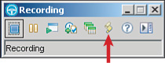

Engaging this button provides you with the option to place a sleep() method into your script. Please refer to [Figure 3.2](https://www.safaribooksonline.com/library/view/software-test-engineering/9780137036455/ch03.html#ch03fig02) for a visual reference.

**Figure 3.2** Script Support Functions Sleep tab

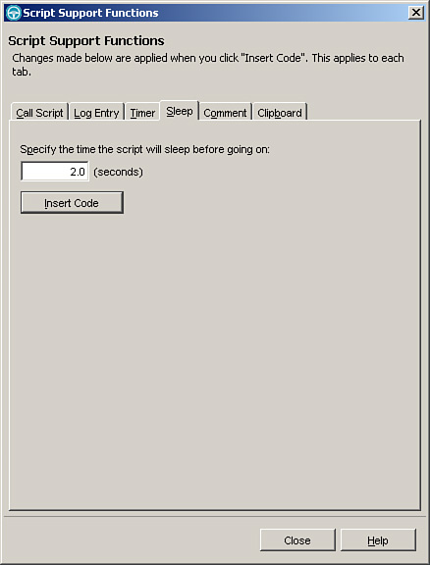

To use this function, you specify the number of seconds that you think your script will need to handle any latency issues with your application. You then click the **Insert** button. If you were using the Eclipse version of Rational Functional Tester, you would see a line in your script that looks like the following:

sleep(2.0);

Otherwise, using the .NET Studio version of Rational Functional Tester, you would see:

Sleep(2.0)

[Listing 3.1](https://www.safaribooksonline.com/library/view/software-test-engineering/9780137036455/ch03.html#ch03ex01) shows what these lines look like in the context of a test script:

**Listing 3.1** Using sleep() / Sleep() in a script

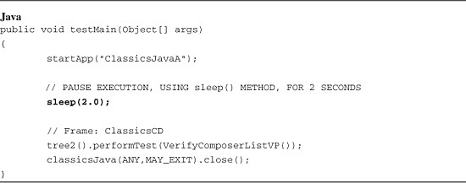

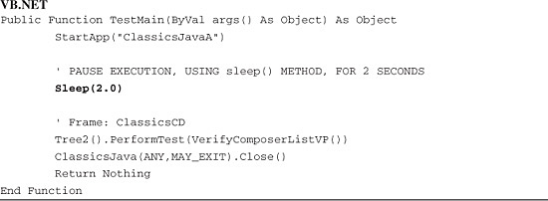

If you execute either of the scripts displayed in [Listing 3.1](https://www.safaribooksonline.com/library/view/software-test-engineering/9780137036455/ch03.html#ch03ex01), execution pauses when it hits the sleep() method. The duration of the pause is determined by the number of seconds that was specified in the argument to the method (the number in the parentheses). In the case of the examples in [Listing 3.1](https://www.safaribooksonline.com/library/view/software-test-engineering/9780137036455/ch03.html#ch03ex01), execution pauses for two seconds.

You also have the ability to code these lines directly into your scripts. For instance, you might not have recorded these delays because you didn’t experience poor performance with your application while recording. However, upon playback of your scripts, you see periodic latency issues that surpass the default synchronization built into Rational Functional Tester. Using, the playback logs, you can find out what object was unable to be found on playback. This enables you to go into your script and code in the necessary sleep() lines. Please remember that you need to provide, as an argument to the method, the number of seconds to pause. This should be a floating number (for example, 2.0, 3.5, and so on).

The benefit of using the sleep() method is that you can now place extended synchronization capabilities right within your scripts, freeing you from the dependency of global playback settings. The downside of using the sleep() method is you are dealing with a static period of time. In other words, your script has to pause for the specified period of time regardless of whether or not the application responds faster than anticipated.

**Waiting for Test Objects to Come into Existence**

When GUI objects aren’t rendered in a timely manner, you simply want your script to wait until they appear. [Chapter 1](https://www.safaribooksonline.com/library/view/software-test-engineering/9780137036455/ch01.html#ch01) discussed the pros and cons of using global delay settings (for example, using Rational Functional Tester’s playback settings). You also just learned about using the sleep() method in the previous section. This is helpful because the delay is specific to a script, releasing your dependencies on the global tool settings. However, it is a static delay. It waits until a specified number of seconds elapse, regardless of whether the GUI object appears sooner or not. This section discusses a happy medium between the global delay settings and the sleep() method.

The Rational Functional Java API provides a useful waitForExistence() method or WaitForExistence() function if you’re using VB.NET. In either case, it comes in two variants. One is dependent upon global playback settings. The other is script-specific.

To use this method, you need to call it from a test object. Simply put, you need to tell your script which object to wait for. You can either type the name of the object, followed by opening and closing parentheses, directly into your code and hit the period key, or you can simply place your cursor in the script where you wish the command to go, right-click the test object in the Test Objects folder (within the Script Explorer view), and click **Insert at Cursor** from the displayed menu. Either of these two options displays an IntelliSense drop-down window (some people refer to this as “code complete”). This window provides you with a list of methods and functions that you can call. Typing the word wait shows you the methods and functions that begin with wait. The waitForExistence() method is among them. [Figures 3.3](https://www.safaribooksonline.com/library/view/software-test-engineering/9780137036455/ch03.html#ch03fig03) and [3.4](https://www.safaribooksonline.com/library/view/software-test-engineering/9780137036455/ch03.html#ch03fig04) show how to call the waitForExistence() method, using the Eclipse and .NET Studio environments, respectively.

**Figure 3.3** Calling the waitForExistence() method—Java language

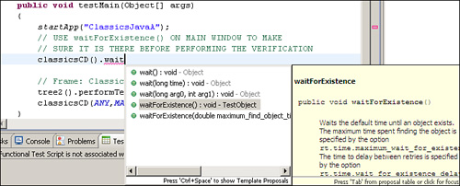

**Figure 3.4** Calling the WaitForExistence() function—VB.NET language

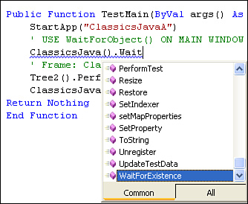

If you use the Java language, you need to append a semicolon at the end of the line. If you use the VB.NET language, you are set and there is nothing further to do. [Listing 3.2](https://www.safaribooksonline.com/library/view/software-test-engineering/9780137036455/ch03.html#ch03ex02) shows you how the command looks in the same Rational Functional Tester script, using Java and VB.NET, respectively.

**Listing 3.2** Using waitForExistence() / WaitForExistence() in a script

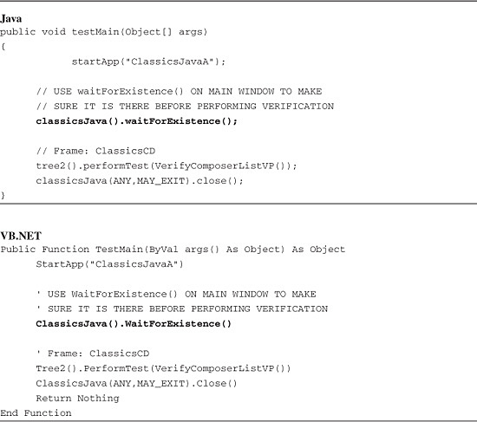

In [Listing 3.2](https://www.safaribooksonline.com/library/view/software-test-engineering/9780137036455/ch03.html#ch03ex02), ClassicsJava() is a test object, representing the main window of the application. You call this test object’s waitForExistence() method to tell your script that it needs to wait until this object appears, prior to executing the next line. The value of this method is that it immediately continues execution of the script after the test object renders on the screen (versus waiting a static period of time). However, this particular variant of the method is dependent upon global delay settings accessed from Rational Functional Tester’s primary playback settings. [Figures 3.5](https://www.safaribooksonline.com/library/view/software-test-engineering/9780137036455/ch03.html#ch03fig05) and [3.6](https://www.safaribooksonline.com/library/view/software-test-engineering/9780137036455/ch03.html#ch03fig06) show these options for Java and VB.NET.

**Figure 3.5** Primary playback settings—waitForExistence() options in Java

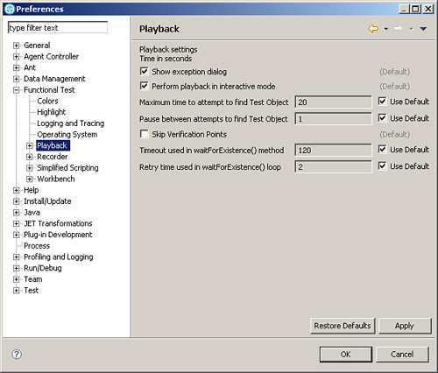

**Figure 3.6** Primary playback settings—WaitForExistence() options in VB.NET

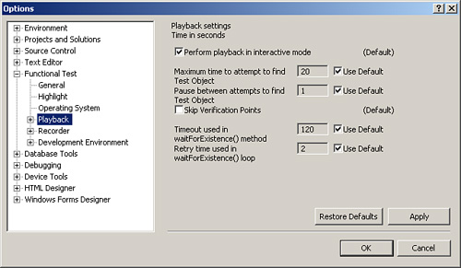

The last two settings are specific to the waitForExistence()/WaitForExistence() method. If you want to change how long it waits or how often it checks for a test object’s existence, you simply override the defaults and supply your own values. You should note that using this variant of the method keeps you dependent upon Rational Functional Tester’s global settings.

To become script-specific, you would use the second variant of this method—waitForExistence(double arg0, double arg1). This enables you to provide the maximum amount of time script playback waits for the object to render (that is arg0). You also enter the amount of time it waits between attempts to find the test object (that is arg1). You specify these two values using seconds. Using this version of the method keeps your scripts independent from the values in the global delay settings for the waitForExistence() method. [Listing 3.3](https://www.safaribooksonline.com/library/view/software-test-engineering/9780137036455/ch03.html#ch03ex03) shows how this would look in both Java and VB.NET.

**Listing 3.3** Using the script-specific version of waitForExistence()/WaitForExistence() in a script

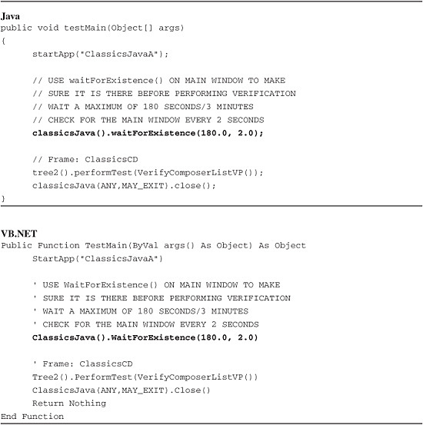

You can see that your script now waits for the main window (for example, classicsJava) of the application for a maximum of 180 seconds, searching for it every two seconds.

Of the three synchronization topics that you have seen thus far, this is the most desirable. It provides you with the ability to have your scripts wait until a test object appears versus waiting for a static amount of time to elapse. Further, it enables you to become script-specific, allowing any tester on your team to run it without having to adjust global playback delay settings.

**Timing How Long Something Takes to Execute in a Script**

Rational Functional Tester provides timers that give an indication of the amount of time that elapsed during script playback. You can use these to estimate how long your scripts take to complete. You can also use these for capturing how long a specific section of your script takes to play back.

The first option that Rational Functional Tester provides is the built-in timer. You can use this option while recording. You can also add it to your scripts later, using two simple lines of code.

While recording, you can define a timer from the GUI recording options, resulting in the appropriate piece of code being written into your script. This option is available from the Script Support Functions button on your Recording toolbar. [Figure 3.7](https://www.safaribooksonline.com/library/view/software-test-engineering/9780137036455/ch03.html#ch03fig07) shows this option.

**Figure 3.7** Script Support Functions—Timer tab

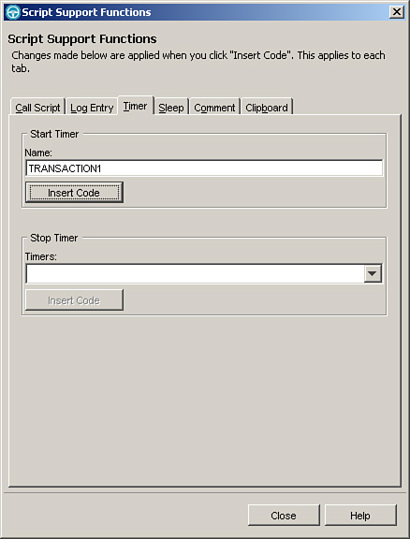

You need to enter only a name for your timer, and then click the **Insert Code** button. This creates the following line in your script:

timerStart("TRANSACTION1");

If you use Rational Functional Tester .NET, you see the following line instead:

TimerStart("TRANSACTION1")

You need to create the corresponding command to stop your timer. To do this, you simply perform the following steps:

**1.** Access your Script Support Functions.

**2.** Choose the **Timer** tab.

**3.** Click the name of timer (you would like to stop) from within the **Timers:** combobox.

**4.** Click the **Insert Code** button.

This will insert either a timerStop("TRANSACTION1"); line or a TimerStop ("TRANSACTION1") line into your script, depending on which version of Rational Functional Tester you are using, Java or .NET, respectively.

These can be added manually, too. You simply type in the necessary timerStart() and timerStop() methods. For instance, [Listing 3.4](https://www.safaribooksonline.com/library/view/software-test-engineering/9780137036455/ch03.html#ch03ex04) shows how to use the timerStart() and timerStop() methods for timing how long it takes for the main window of the application to render.

**Listing 3.4** Using timers in a script

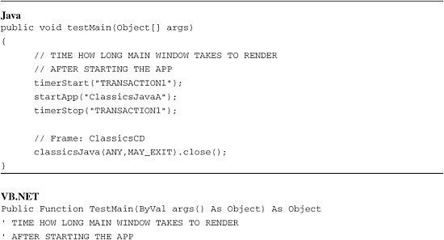

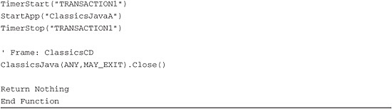

The prior two scripts result in a couple of events being written into the test log. The first is the timer getting started by the script. The second is the timer stopping. The stop event also displays the amount of time that elapsed. [Figure 3.8](https://www.safaribooksonline.com/library/view/software-test-engineering/9780137036455/ch03.html#ch03fig08) shows what these events look like in the HTML log.

**Figure 3.8** Timer events in the HTML log

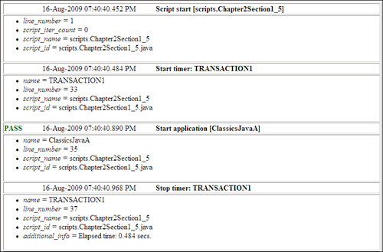

Note that Rational Functional Tester’s Script Assure technology can influence timers. If a test object’s property values change and it is wrapped in between timer commands, you can, and often do, see excessive elapsed times in your log files. This is because the time it takes to find a test object gets captured and added into the timer.

One downside of Rational Functional Tester’s timers is that they don’t return a value for external consumption. For instance, you might want to write the elapsed time out to an external file (for example, if you have a test harness that has its own logging mechanism). This is where you can turn to the native scripting language, Java, or VB.NET.

Java’s System class provides the currentTimeMillis() method for capturing transaction times. It returns a long data type. It is a native method that directly calls out to the operating system. Therefore, its resolution can vary when you run your tests on different machines running different operating systems. [Listing 3.5](https://www.safaribooksonline.com/library/view/software-test-engineering/9780137036455/ch03.html#ch03ex05) revisits the waitForExistence(double arg0, double arg1) method. This time the System.currentTimeMillis() method is used to capture how long the waitForExistence() method actually had to wait.

**Listing 3.5** Capturing elapsed times using native Java capabilities

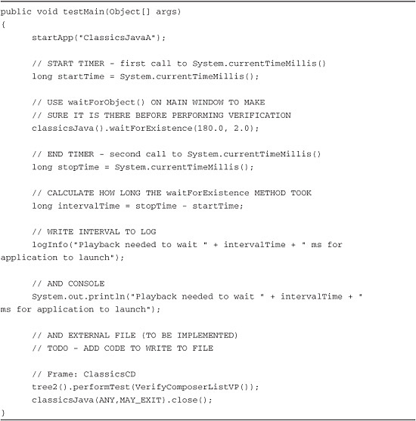

VB.NET’s System namespace offers the DateTime and TimeSpan structures for acquiring elapsed times. To use these, you first obtain the value contained in DateTime’s Now property to capture the start time. You capture Now’s value again when you want to get the stop time. To gather the total elapsed time, you use the TimeSpan structure and initialize it with the difference between your stop and start times. Depending upon how you want to view the elapsed time, TimeSpan lets you display it in hours, minutes, seconds, milliseconds, and so on. [Listing 3.6](https://www.safaribooksonline.com/library/view/software-test-engineering/9780137036455/ch03.html#ch03ex06) shows how this comes together. This builds off of an earlier script that used the WaitForExistence() function.

**Listing 3.6** Capturing elapsed times using native VB.NET capabilities

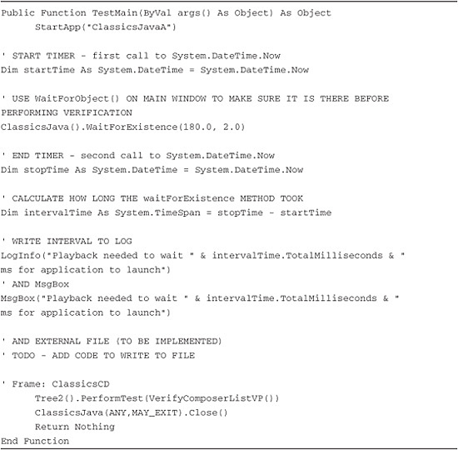

Synchronization and timing are two critical tools in an automation engineer’s toolbox. They help you determine how long a piece of your script takes to execute and, perhaps more importantly, they help you keep your scripts—or pieces of them—in synch with your application’s playback.

This section covered the appropriate timing and synchronization methods provided by Rational Functional Tester. You saw how you can use delays to wait a specified number of seconds. You also saw how you can tell your scripts to wait until a desired test object appears. Lastly, you learned how to use timers to capture how long a piece of your script takes to execute.

You should now be able to apply the appropriate techniques and script code to deal with any latency issues that appear in the application you test. You can use timers to determine the duration of the latencies. You can then select the appropriate method for dealing with them.

**Working with Test Objects**

[Chapter 1](https://www.safaribooksonline.com/library/view/software-test-engineering/9780137036455/ch01.html#ch01) discussed the use of test object maps at a high level. It also provided an overview on test objects including adding, modifying, and deleting them. Rational Functional Tester records and uses these objects to interact with an application’s user interface. You begin to unleash the power of Rational Functional Tester when you choose to manipulate these objects.

Test objects offer more than what you see when you are done recording. Typically, a recorded script shows you actions against test objects. You see things such as clicks, double-clicks, text-entry commands, and so on. When you dig deeper into these, you find that you can access interesting information. You can programmatically access properties that describe the object and the data that it contains. You also have access to an object’s methods that can be invoked from your script. [Chapter 10](https://www.safaribooksonline.com/library/view/software-test-engineering/9780137036455/ch10.html#ch10), “[Advanced Scripting with Rational Functional Tester TestObjects](https://www.safaribooksonline.com/library/view/software-test-engineering/9780137036455/ch10.html#ch10),” covers this topic. For the purposes of this chapter, you examine the basics of accessing test object properties and data using the scripting language.

After you have the basics of programmatically accessing test object data, you get a look at how you can start encapsulating your custom scripting to develop your own methods and functions. This is a great means for other members of your team to take advantage of the work you did, avoiding any redundant custom scripting.

**Working with the Clipboard Object**

Rational Functional Tester gives you a type of verification point that works with textual data on the Windows Clipboard. You might ask, “Why would I want to use the Windows Clipboard with Rational Functional Tester?” You want to do this for several reasons, but in most cases, it comes down to an easy way to get around object recognition difficulties. Often you need a test script to do something, such as checking a value, and if the normal way to do this (in this example, using a verification point) doesn’t immediately work, using the Clipboard might be the fastest way to make it work.

Getting a test script to work reliably with the application interface you are testing often comes down to robust object recognition. Dealing with object recognition is covered in more detail in [Chapter 8](https://www.safaribooksonline.com/library/view/software-test-engineering/9780137036455/ch08.html#ch08), “[Handling Unsupported Domain Objects](https://www.safaribooksonline.com/library/view/software-test-engineering/9780137036455/ch08.html#ch08),” and in [Chapter 9](https://www.safaribooksonline.com/library/view/software-test-engineering/9780137036455/ch09.html#ch09), “[Advanced Rational Functional Tester Object Map Topics](https://www.safaribooksonline.com/library/view/software-test-engineering/9780137036455/ch09.html#ch09).” In some cases, you want to follow that information to fully implement Rational Functional Tester’s recognition and interface with the test objects. The reason that you might not follow that approach, but instead use the Clipboard, usually has to do with how quickly you need to get something to work. Do not think of the Clipboard approach as a work-around or interim solution, though, as it is often the most effective and efficient way to automate a test procedure.

You use the Clipboard for handling object recognition with Rational Functional Tester, which specifically means getting, setting, or otherwise using values from the application under test or associated applications. You might do this for any of the following reasons:

• Verifying some functionality or output from the application

• Controlling the timing of your test scripts

• Manipulating the flow of the test procedures

• Logging additional information into the test results

When you use this technique, you record steps to copy and/or paste data to the Clipboard, and then use it as a kind of data source. The Clipboard can be used as an intermediate place to hold data from the application under test, and Rational Functional Tester can get data from the Clipboard or send data to it. You can also test anything that gets onto the Clipboard with a verification point.

There are three general approaches to using the Clipboard with automated testing:

**1.** Verifying some value from the application

**2.** Getting some value from the application to use in the test

**3.** Sending some value from the test to the application

For each of these tactics, you usually record some steps to select and copy data from some GUI, and then add some Clipboard actions into the test script. This chapter describes several examples, with specific steps, for each of the three approaches.

You do not have to manually code the methods previously described; you can simply use the Recorder toolbar to generate the Clipboard code. You add these Clipboard actions much like you would other kinds of verification points or script actions. The wizards for adding Clipboard actions into a test are found in the Script Support Functions on the Recorder toolbar.

[Figure 3.9](https://www.safaribooksonline.com/library/view/software-test-engineering/9780137036455/ch03.html#ch03fig09) illustrates how to access the Clipboard actions from the Rational Functional Tester Recorder toolbar.

**Figure 3.9** Recorder toolbar—the Clipboard

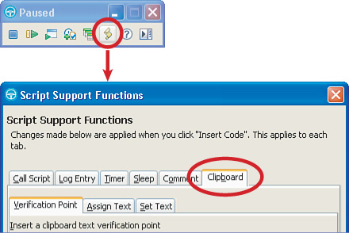

Like all of Rational Functional Tester’s script support functions, you need to click **Insert code** to add the commands to your test script.

The first consideration you have when using the Clipboard is determining exactly how you can select and copy, or perhaps paste, data to and from the Clipboard. In some cases, you might select text using a mouse click and drag, followed by a Ctrl+C keyboard shortcut. In other cases, you might have a menu option in the application under test to copy information to the Clipboard. You might have to use a combination of interactions with the application under test, the operating system, various keyboard inputs, and right-clicking or other menu selections.

The exact method used to get data to and from the Clipboard is of critical importance to the resilience of the automated test script. Some of the steps that you record, such as clicking and dragging, rely on coordinates within an object. These methods are therefore more susceptible to playback failure. You should always strive to record actions that are most likely to replay in the maximum (and reasonable) test environments and playback conditions.

The following looks at several related examples of creating test scripts that use the Clipboard and starts with one possible scenario of creating automated test scripts leveraging the Clipboard. This is not intended to be the most realistic scenario possible, but it illustrates different ways of using the Clipboard with Rational Functional Tester.

In this scenario, you have to test a system that includes an older reporting component. Rational Functional Tester can recognize only parts of this component’s interface and doesn’t seem to automatically capture a particular value: the current job number. This alphanumeric string has to be checked against expected values and it is used as an input value to another test. Finally, because this is a lower priority test case, you cannot spend too much time developing the test script.

You can figure out how to get Rational Functional Tester to recognize the objects and properties to access the job number value, but that might take time. You realize that the job number field can be easily selected and copied to the Clipboard, so you use the Clipboard to quickly get a working automated test script.

First, you create a Clipboard verification point for the job number value. This differs from other verification points in that you do not directly access the object or properties to get the value. You can record a test script to do this as follows:

**1.** Record the initial steps of the test script, getting to the point where the job number (the value we want to verify) is displayed.

**2.** Select the job number text and copy it to the Clipboard. A robust method for doing this could be tabbing to the field if the application GUI is not likely to change.

**3.** Open the **Script Support Functions** from the Recorder toolbar, and click **Clipboard** > **Verification Point Tab** (see [Figure 3.10](https://www.safaribooksonline.com/library/view/software-test-engineering/9780137036455/ch03.html#ch03fig10)). You will see the value that was copied in the verification value field.

**Figure 3.10** Clipboard verification point

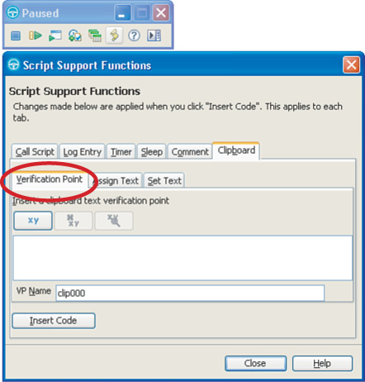

Note

You have the option of creating a regular expression from the Clipboard value. This works the same way as other verification points.

Clearing the Clipboard

Any time you are using the Clipboard as part of a procedure, it is a good practice to clear the Clipboard as an initial step. Copying to the Clipboard normally replaces any prior data, but clearing it first ensures that you are not inadvertently including unwanted data. The exact steps to do this depend on the operating system and version and the applications you use.

**4.** Enter a descriptive name for the verification point in the VP Name field.

**5.** Click **Insert Code,** and then click **Close** to exit the Script Support Functions and return to recording mode.

At this point, the script contains the code for a Clipboard verification point, as shown here:

*getSystemClipboard*().performTest(JobNumberVP());

You now get the job number value and store it in a local variable within the test script. You can record a test script to do this as follows:

**1.** Record any initial steps of the test script or continue the previous example, getting to the point where the job number (the value we want to capture) is displayed.

**2.** Select the job number text and copy it to the Clipboard. If you combine this with the previous verification point example, you can skip directly to the next step.

**3.** Open the **Script Support Functions**, and click **Clipboard** > **Assign Text Tab** (see [Figure 3.11](https://www.safaribooksonline.com/library/view/software-test-engineering/9780137036455/ch03.html#ch03fig11)).

**Figure 3.11** Getting a value from the Clipboard

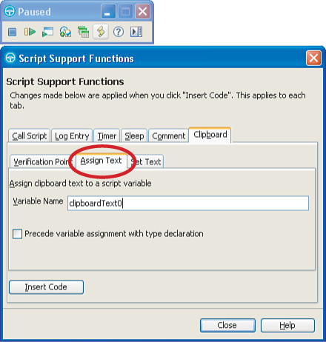

Note

You do *not* see the value that was copied to the Clipboard here. If you want to check that the right value was copied, you can switch to the Verification Point tab where you will see it, and then switch back to the Assign Text tab.

**4.** Enter a descriptive name for the script variable in the Variable Name field, and then select **Precede variable assignment with type declaration**.

**5.** Click **Insert Code**, then click **Close** to exit the Script Support Functions and return to recording mode.

At this point, the script contains the code for a new string variable to hold whatever was copied to the Clipboard, as shown here:

String JobNum = getSystemClipboard().getText();

This variable can now be used for any number of reasons within the test.

You also have the ability to send data to the Clipboard. You might want to do this if you need to test your application’s paste function. If you set the data in the Clipboard immediately before performing a paste function, you can ensure that you know what should be pasted into your application. Another reason you might do this is for continuity. For example, if one piece of your application provides a record number, you might wish to store it in a variable (for example, JobNum in the preceding line of script). You can then use this variable to paste into the piece of your application that does a record lookup. In any case, setting the Clipboard is easy. You simply use the following line of code in your script:

*getSystemClipboard*().setText(JobNum);

Returning to the scenario, you now need to enter a new job number, different from the current one, into the application. You want to paste this value from the Clipboard into the application GUI field. You therefore need to set the value contained in the Clipboard. You might calculate or look up the particular value in several ways, but for this example, you simply show a static string. You can record a test script to do this as follows:

**1.** Record any initial steps of the test script or continue the previous example, getting to the point where you enter the new value.

**2.** Open the **Script Support Functions**, and then click **Clipboard** > **Set Text Tab**. The value field on this tab is empty (shown in [Figure 3.12](https://www.safaribooksonline.com/library/view/software-test-engineering/9780137036455/ch03.html#ch03fig12)).

**Figure 3.12** Sending a value to the Clipboard

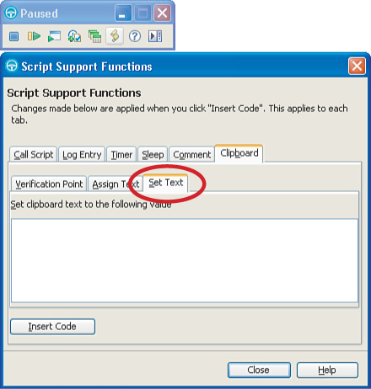

**3.** Enter the value that you want to send to the Clipboard. You might simply enter a placeholder value when you are recording and then replace it in the script to some calculated or retrieved variable (for example, JobNum).

**4.** Click **Insert Code**, then click **Close** to exit the Script Support Functions and return to recording mode.

At this point, the script now contains the code to set the value of the Clipboard, as shown here:

*getSystemClipboard*().setText("SomeValue");

As mentioned in step 3, you might want to replace the hard-coded value entered during recording mode (IncrementedJobNumber) with some variable or other value. An incomplete example of this is shown in following code snippet.

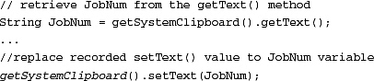

Instead of using the recorder, you might want to manually add the code for Clipboard interactions. This is easy to do because you would have to add only one line of code for each type of Clipboard action, not counting the lines of script to select, copy, or paste the data. An example of a line to capture something to the Clipboard is:

someTextField().inputKeys("{ExtHome}+{ExtEnd}^c");

The preceding line of code performs the following steps:

**1.** Press the **Home** key (that is {ExtHome})—This places the cursor at the beginning of the field.

**2.** Perform a **Shift+End** keystroke combination (that is +{ExtEnd})—This selects everything in the field (from the beginning to the end of it).

**3.** Perform the **Ctrl+C** keystroke combination (that is ^c)—This executes the copy function of the application.

After this, you can manually add the following line to your script for a Clipboard verification point:

*getSystemClipboard*().performTest(myClipVP());

The Rational Functional Tester API has a public interface IClipboard in the com.rational. test.ft.script package that defines the set of methods exposed for a Clipboard. The three methods in this are:

• getText—Returns a copy of the text from this Clipboard.

• setText—Copies the supplied text value to this Clipboard.

• performTest:—Captures, compares, and logs active Clipboard text against the supplied baseline data.

Note

There are four variations of the performTest method for various verification point settings such as retry and timeout values. Refer to the Rational Functional Tester API reference in the online Help for more information.

There are several things to consider when using the Clipboard with Rational Functional Tester:

• The Clipboard is often used to verify, get, and set data without mapping and directly accessing objects and properties. This can make script maintenance more difficult because you do not have an object map of the objects containing the values.

• The steps used to capture data to the Clipboard or paste data from it might be less resilient and more susceptible to playback problems. This can be a risk if you have to resort to click and drag or other actions using coordinates.

• There is a risk with the system Clipboard that scripts might not play back the same way in different test environments. Although this should ideally work the same way on Windows and Linux operating systems, it can also fail on the same operating system due to different conditions in the test environment.

**Viewing an Object’s Properties**

Rational Functional Tester has a useful (and often overlooked) utility called the Test Object Inspector that you can use to examine a wealth of information about test objects (including properties). No coding is required to use the Inspector. It is a design-time tool that can often be used to gather information you need to write your own code. It’s powerful because it shows you *almost* everything that you can manipulate in the test object through Rational Functional Tester.

To launch the Inspector, click **Run** > **Test Object Inspector** (in Eclipse) or **Tools** > **Test Object Inspector** (in Visual Studio). After the Inspector displays, by default it remains on top of all windows on your Desktop. As you move your mouse over objects, the Inspector captures information and displays it in the Inspector window. To inspect any object on your desktop, simply hover over the object and press the Pause key on your keyboard. This tells the Inspector to freeze with the information currently captured, and enables you to move your mouse and not lose the information currently displayed in the Inspector window.

After you pause it, you can view information about the test object. The Inspector can show five broad categories of information: Parent Hierarchy, Inheritance Hierarchy, Properties, Non-Value Properties, and Method information.

To select what you want the Inspector to display, press the corresponding button on the toolbar or make your selection under the Inspector’s Show menu. In addition to these broad categories, there are options that you can turn on and off under the Options menu. The following examines five examples:

• **Parent Hierarchy—**Shows the hierarchical path from the test object to the top-level window. For example, if you inspected the Google Search button on [www.google.com](http://www.google.com/) ([http://www.google.com](http://www.google.com/)), the Inspector shows what is displayed in [Figure 3.13](https://www.safaribooksonline.com/library/view/software-test-engineering/9780137036455/ch03.html#ch03fig13).

**Figure 3.13** Test Object Inspector—Parent Hierarchy for Google application

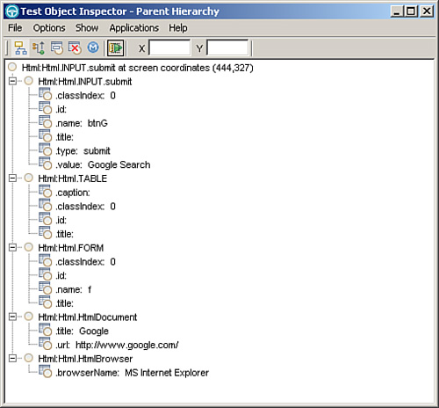

The Inspector displays the same recognition information (hierarchy and recognition property names and current values) that the object map would store for the button, except that the tree is upside down (the browser window is the bottom, not at the top, as in the object map) and the hierarchy is flattened (there are no indentations).

You might turn on this option when viewing a test object’s parent hierarchy that does a full disclosure of sorts. This option expands what’s displayed in the Parent Hierarchy to include *nonmappable* objects. To turn this option on, toggle **Hide not Mappable** under the Options menu. Nonmappable objects are objects that RFT does not think are interesting and does not, therefore, add to the object map (RFT doesn’t record any actions against nonmappable objects). However, sometimes you want to know about nonmappable objects. In such situations, turning on this option is useful. [Figure 3.14](https://www.safaribooksonline.com/library/view/software-test-engineering/9780137036455/ch03.html#ch03fig14) shows the Parent Hierarchy for the Google Search button.

**Figure 3.14** Test Object Inspector—the Parent Hierarchy for Google application, nonmappable objects

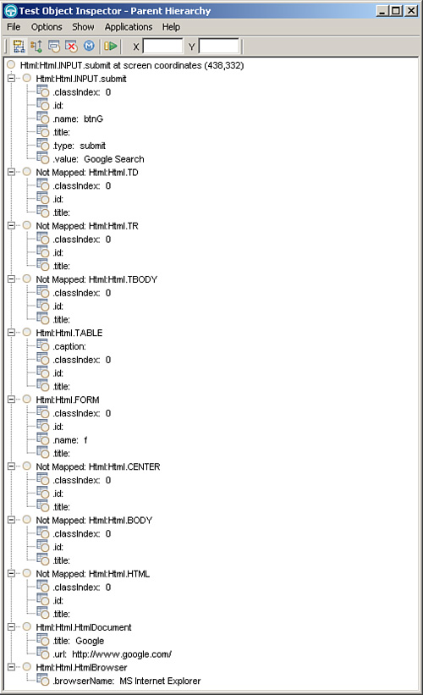

Without displaying nonmappable objects, the parent of the button is the HTML table; when you include nonmappable objects, you see that the parent (the real parent in a sense) is the TD HTML element. To differentiate between these two views of test object parentage, you say that the table is the button’s *mappable parent* and the TD is its *nonmappable* parent. The RFT API differentiates between mappable and nonmappable parents and children.

• **Inheritance Hierarchy—**Shows class inheritance hierarchy of the test object’s class. This option does not apply the HTML test objects. [Figure 3.15](https://www.safaribooksonline.com/library/view/software-test-engineering/9780137036455/ch03.html#ch03fig15) shows the inheritance hierarchy for the Place Order button in Classics.

**Figure 3.15** Test Object Inspector—Inheritance Hierarchy

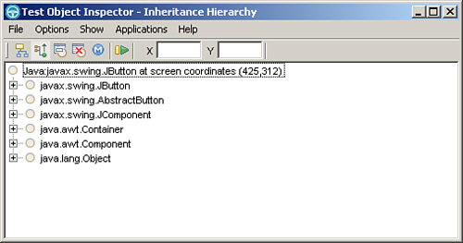

Here, the Inspector shows that the (Java) class of the button is javax.swing.JButton, which inherits from AbstractButton, which inherits from JComponent, and so on up to Object, the root class of all classes in Java.

• **Properties—**Shows all the test object’s value properties (property names and values). [Figure 3.16](https://www.safaribooksonline.com/library/view/software-test-engineering/9780137036455/ch03.html#ch03fig16) shows what you get when you examine the properties of the Place Order button in Classics.

**Figure 3.16** Test Object Inspector—properties

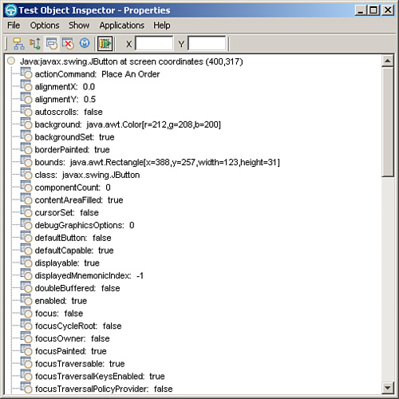

• **NonValueProperties—**Shows all the test object’s nonvalue property names and each nonvalue property’s data type. Using the Place Order button, the Inspector shows the following nonvalue properties (displayed in [Figure 3.17](https://www.safaribooksonline.com/library/view/software-test-engineering/9780137036455/ch03.html#ch03fig17)).

**Figure 3.17** Test Object Inspector—nonvalue properties

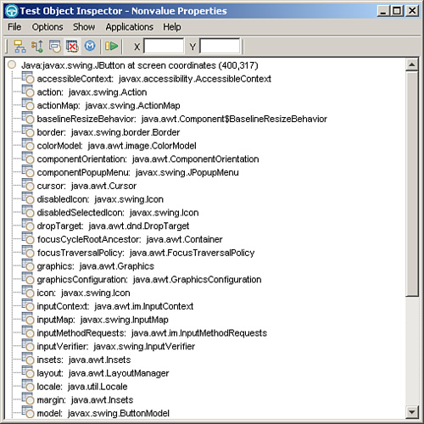

• **Method Information—**Shows all the methods that can be invoked directly on the test object via RFT’s invoke() method (which we cover in [Chapter 10](https://www.safaribooksonline.com/library/view/software-test-engineering/9780137036455/ch10.html#ch10)). The methods are grouped by the test object class’ inheritance chain. An example of this is shown in [Figure 3.18](https://www.safaribooksonline.com/library/view/software-test-engineering/9780137036455/ch03.html#ch03fig18).

**Figure 3.18** Test Object Inspector—Method Information

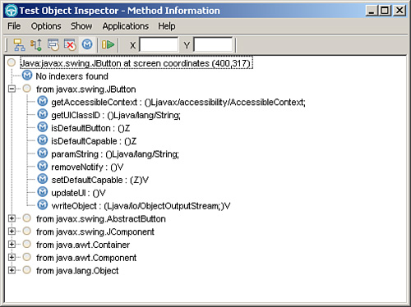

To the right of each method name, the Inspector shows the method’s JNI signature (argument list and return type).

What is the difference between a value property and a nonvalue property? A *value property* is a property whose value Rational Functional Tester can reconstruct in its own JVM and store and compare it to other values in another context. There is a practical application of this: When you perform a Properties verification point, for example, Rational Functional Tester captures and must then store (as a baseline) the values of the properties that are being verified. When the verification point is executed, Rational Functional Tester must know how to compare the baseline values with the actual values. The properties Rational Functional Tester can manipulate in this manner are referred to collectively as *value properties*. Properties whose values Rational Functional Tester does not know how to store and compare are called *nonvalue properties*.

If you look at the list of value properties, you can see that the value of each property is either a String (actionCommand), boolean (enabled), numeric (alignment), or a Java class that consists of numeric fields (Rectangle and Color). These values can easily be restructured, stored, and compared in another context (RFT’s JVM or a baseline VP file).

The nonvalue properties, on the other hand, are different in nature. In the nonvalue property list, you see properties such as graphicsConfiguration, icon, and cursor. It’s not difficult to appreciate that it is difficult (at best) for RFT to store the value of a Cursor object or any of the other nonvalue properties. Both value and nonvalue property values are available to you through coding.

**Retrieving All Properties of a Test Object**

The two sets of properties discussed in the “[Viewing an Object’s Properties](https://www.safaribooksonline.com/library/view/software-test-engineering/9780137036455/ch03.html#ch03sec1lev7)” section—value and nonvalue properties—can be retrieved from a test object in a script by invoking getProperties() and getNonValueProperties(), respectively. Each of these methods returns a Hashtable of property names and values. For nonvalue properties, the values are references to the actual objects in the target application (remote JVM). [Listing 3.7](https://www.safaribooksonline.com/library/view/software-test-engineering/9780137036455/ch03.html#ch03ex07) shows three methods: one that retrieves value properties, one that retrieves nonvalue properties, and one that calls both methods.

**Listing 3.7** Methods for retrieving all properties of a test object

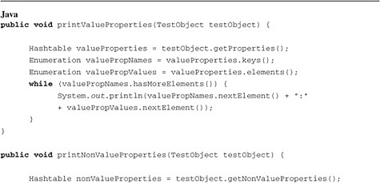

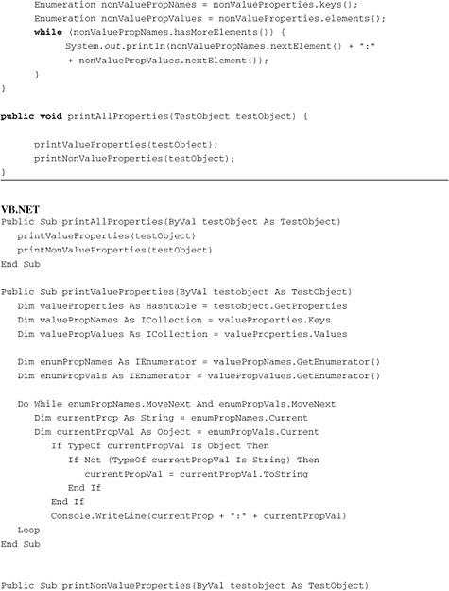

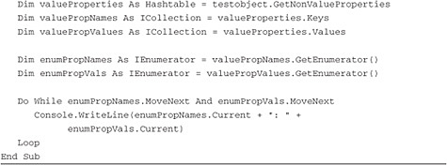

**Retrieving the Value of a Single Property**

To retrieve the value of a single property, use the getProperty() method in the TestObject class. You can use getProperty() with both value and nonvalue properties. In this section, the discussion is limited to value properties. The signature of getProperty() for Java is:

Object getProperty( String propertyName )

The signature of getProperty() for VB.NET is:

Function GetProperty( propertyName as String) as Object

The argument is the name of the property whose value you want to retrieve. Because getProperty can be used with any value or nonvalue property, the return type is generic Object. You typically want to cast to a specific type (for example, String).

For value properties, you can even use Rational Functional Tester to generate the code for you.

**1.** Place your cursor at the line in your script where you want the code to generate.

**2.** Insert recording.

**3.** Launch the Verification Point and Action Wizard.

**4.** Click the desired test object.

**5.** In the Select an Action window, click **Get a Specific Property Value**.

**6.** The wizard will then display all the test object’s value property names and values. Click the property you want, and then click **Next**.

**7.** In the Variable Name window, enter a variable name to hold the returned value (RFT generates a variable name for you but you will typically always want to change the variable name), and click **Finish**.

If you selected the label property, Rational Functional Tester generates the following code.

In VB.NET:

Dim buttonLabel As String = PlaceOrder().GetProperty( "label" )

In Java:

String buttonLabel = (String)placeOrder().getProperty( "label" );

In Java, you need to explicitly cast to the correct type. For example, if you retrieve a non-String property value, such as the Background property, you see:

java.awt.Color buttonBackground =  
(java.awt.Color)placeOrder().getProperty( "background" );

If you pass a property name that does not exist in the object, Rational Functional Tester throws a PropertyNotFoundException.

As you become more comfortable with Rational Functional Tester, you can rely less on the wizard to generate code for you.

**Programmatically Retrieving Data from an Object in My Application**

Retrieving data from objects in your application is a critical and fundamental task. You might need to get the data so that you can use it at a later point in your test; you might get it because you’re creating your own verification point. No matter what your motivation is for pulling data from an object, the RFT API makes extracting data easy.

For the purposes of this chapter, the world of test objects is divided into two broad categories: those in which the RFT Verification Point Wizard sees data and those in which the RFT Verification Point Wizard doesn’t see data. The TestObject techniques discussed in this chapter (with the exception of the “[Working with the Clipboard Object](https://www.safaribooksonline.com/library/view/software-test-engineering/9780137036455/ch03.html#ch03sec1lev6)” section) are limited to the former category of test objects, which is covered in other chapters.

You use one of two methods to get data from a test object: getProperty() or getTestData(). getProperty() is appropriate if the data is available as a property of the test object and the format of the data as a property value suites your needs. For example, if you want to get the visual text on a button (such as the Place Order button in Classics or the Search button at [www.google.com](http://www.google.com/)), getProperty() would work fine. If you examine these objects using the Test Object Inspector (see the “[Viewing an Object’s Properties](https://www.safaribooksonline.com/library/view/software-test-engineering/9780137036455/ch03.html#ch03sec1lev7)” section), you can see that in Classics, you need to get the value of the label property; the Google button would require that you get the value property.

Things become more interesting when the data you’re interested in is available as a property, but not in the desired format. For example, on the Rational Support home page, there is a list of products (see [Figure 3.19](https://www.safaribooksonline.com/library/view/software-test-engineering/9780137036455/ch03.html#ch03fig19)).

**Figure 3.19** Rational Support site

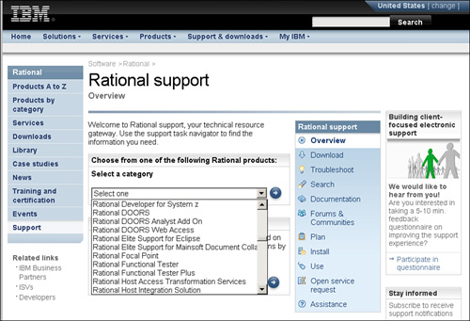

Imagine you wanted to get the list values. Examining the list under the Test Object Inspector microscope reveals a .text property whose value is the contents of the list. There’s a problem, though: It’s one big string—you don’t know where the breaks between items are. Sometimes it is not a critical issue. For instance, you might just want to know if “Functional Tester” appears anywhere in the list. If that is the case, you can simply use getProperty() to capture the .text property and be done with it. However, what if you want to know how many items are in the list? To achieve this, getProperty() does not suit your needs. In this instance, the usage of getTestData() would aid your efforts.

If you run Rational Functional Tester’s Verification Point and Action Wizard and click **Data Verification Point**, you see that Rational Functional Tester is able to identify each list item discretely. Because Rational Functional Tester’s Data Verification Point Wizard is able to capture the data, you can capture the data in code. In fact, any data that the Rational Functional Tester Data Verification Point Wizard is able to capture can be retrieved programmatically in a script.

Your script can retrieve any data from a test object that is accessible to the Data Verification Point Wizard by invoking the getTestData() method on the test object. Here is the method signature:

ITestData getTestData( String testDataType )

getTestData() does precisely what its name suggests: It gets and returns data from a test object. That’s it. It does not verify anything. It requires a String argument—the *test data type*—to capture from the test object. The notion of a test data type requires some explanation.

**Test Data Types**

Recall that when you use Rational Functional Tester’s Verification Point Wizard, you have to indicate to the wizard which test data to verify. For example, if you’ve selected a list object (as in the case of the Rational Support site example), you have to express if you want Rational Functional Tester to verify all the values in the list or just the selected elements. You can see this in [Figure 3.20](https://www.safaribooksonline.com/library/view/software-test-engineering/9780137036455/ch03.html#ch03fig20).

**Figure 3.20** Verification Point and Action Wizard

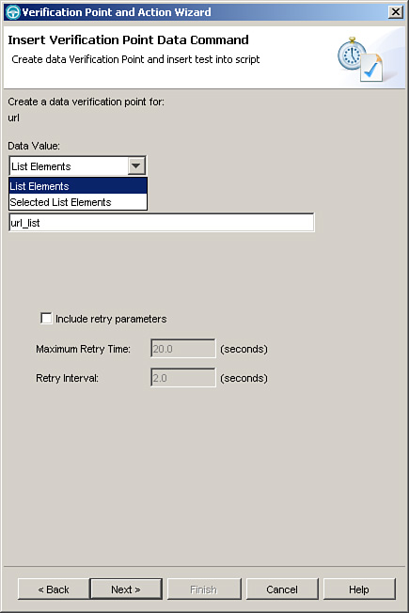

The argument passed to getTestData() indicates to getTestData() that same detail that you express to the Verification Point Wizard when you select a value in the Data Value list. In the case of a recorded verification point, it tells Rational Functional Tester which data to retrieve and verify; in the case of getTestData(), it indicates which data to retrieve and return to the caller of getTestData().

**ITestData**

getTestData() returns the data as a Java interface type: ITestData. The ITestData interface is inherited by several subinterfaces, each of which has methods to store and manipulate specific types of data, for example, ItestDataList (for data in lists), ITestDataTable (for data in tables), and ITestDataTree (for data in trees). Each of these interfaces has methods to query and extract data in the manner appropriate for that data structure. For example, if you retrieved the data in a table, you might want to know how many columns and rows of data there are. You might also want to get all the values in row 3 or column 2. ITestDataTable has methods that make this possible in an intuitive fashion. When working with lists, you might want to know how many items are in the list and get all the values. ITestDataList has methods to do this.

Even though the signature of the return type of getTestData() is ITestData (the base interface type), what will actually be returned is a reference to a subinterface of ITestData, for example, ITestDataTable. Even though you can always treat any of the returned data as base ITestData (that is you can upcast the returned reference), you almost always assign to a variable of the specific subinterface type so that you can call the specific methods available in the subtype. In the case of Java, you explicitly downcast; in VB.NET, you can use an implicit downcast. For example (don’t worry here about the argument to getTestData(); the focus here is on the downcasting), Java:

ITestDataTable iData = (ITestDataTable)someTable().getTestData(  
"contents" );

In VB. Net:

Dim iData As ITestDataTable = someTable.GetTestData( "contents" )

Using getTestData() successfully requires that you:

• Know the appropriate test data type argument for the test object in question.

• Know which methods to use in the returned ITestData to access the data elements.

In the next sections, we look at how to acquire this knowledge.

**Determining a Test Object’s Valid Test Data Type Arguments to getTestData()**

You can use two techniques to determine a test object’s valid data type arguments:

**1.** Call getTestDataTypes() on the test object you need to get data from. getTestDataTypes() is a method in the TestObject class that returns a Hashtable, which holds the same information that the Rational Functional Tester Verification Point Wizard displays (and then some).

**2.** Right-click the test object in the Script Explorer, and click **Interface Summary**. This displays a page in the Rational Functional Tester documentation that summarizes how it works with the selected test object, including the valid data types it can use.

For example, if you invoke getTestDataTypes() on the Orders table in the Classics sample application (**Admin > Orders**) and print the returned hashtable to the console (Output window in Visual Studio), you have the following:

In Java:

System.out.println( orderTable().getTestDataTypes() );

In VB.NET:

Console.WriteLine(someTable.GetTestDataTypes)

You see something similar to what is displayed in [Figure 3.21](https://www.safaribooksonline.com/library/view/software-test-engineering/9780137036455/ch03.html#ch03fig21).

**Figure 3.21** Console output of orderTable().getTestDataTypes()

image

The keys in the hashtable (contents, visible contents, selected, and selected and visible selected) are the valid test data type arguments to getTestData() for the test object in question; the value of each hashtable key is a description (for you, not Rational Functional Tester) of the test data type. Based on that output, the following are all valid calls to make on the Orders table:

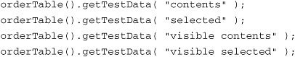

**Using getTestData to Extract Data from a Text Field**

The first example of using getTestData() is one that might not initially seem interesting. You can use getTestData() to retrieve data from text fields. To do so, pass getTestData() an argument of “text;” it returns the text as ITestDataText, which is the simplest subinterface in the ITestData family to work with. It’s simple because you need to know only one method to get the data into a usable string: getText(). As an example, look at these two text fields:

• The Search field at [www.google.com](http://www.google.com/) <[http://www.google.com](http://www.google.com/)> (HTML domain)

• The Name field on Classics’ Place an Order window (Java domain)

If you fire up and point the Inspector (see the “[Viewing an Object’s Properties](https://www.safaribooksonline.com/library/view/software-test-engineering/9780137036455/ch03.html#ch03sec1lev7)” section in this chapter) at each of these objects, you can see that in the case of the HTML text field, you need to get the value property. In the case of the Java Swing field, you need to get the text property. If you use getTestData(), in both cases, you pass an argument of text. This is useful if you want to create a generic method that retrieves text (expressed as a single string) from any type of test object. [Listing 3.8](https://www.safaribooksonline.com/library/view/software-test-engineering/9780137036455/ch03.html#ch03ex08) shows both a Java and VB.NET example of using getTestData().

**Listing 3.8** Getting data from a text field

image

image

Notice that in Java, you must explicitly cast to ITestDataText.

**Using getTestData to Extract Data from a List**

Lists are relatively easy objects to start with, though there are two twists that follow. The first issue is the test data types:

First twist: If you retrieve the selected element from a Swing JList, the data is returned as ITestDataText (in this case, you then call getText() and you’re done); for any other type of list, the data is returned as ITestDataList.

Second twist (relates only to ITestDataList): Getting the individual data values out of the ITestDataList requires a little more work than you might like. You work with three interface types: ITestDataList, ITestDataElementList, and ITestDataElement.

[Tables 3.1](https://www.safaribooksonline.com/library/view/software-test-engineering/9780137036455/ch03.html#ch03tab01) and [3.2](https://www.safaribooksonline.com/library/view/software-test-engineering/9780137036455/ch03.html#ch03tab02) show the most commonly used methods in each of these interfaces.

**Table 3.1** List Object Data Types

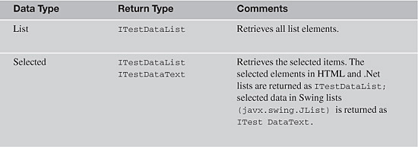

**Table 3.2** List Object Interface Methods

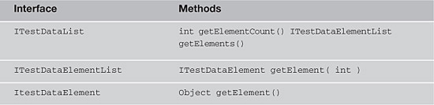

At a high level, this is the algorithm to get list data:

**1.** Call getTestData() on your list test object. The data will be returned as ITestDataList.

**2.** On the returned ITestDataList, call getElementCount() on the returned ITestDataList to find out how many elements are in the ITestDataList.

**3.** Call getElements() on the returned ITestDataList. This returns another interface: ITestDataElementList.

**4.** From the returned ITestDataElementList, you can now get any individual element by calling getElement(int). The integer argument passed to getElement() is the index of the element you want (you start counting at zero). getElement() returns yet another interface type: ITestDataElement.

**5.** After you have an individual list item as an ITestDataElement, you can call getElement() to get actual data value. getElement() returns the data as an Object, so if you’re working in Java, you need an explicit cast to a String.

[Listing 3.9](https://www.safaribooksonline.com/library/view/software-test-engineering/9780137036455/ch03.html#ch03ex09) offers two examples: one that retrieves all elements and one that retrieves selected elements. In both examples, the data is returned as an array of Strings.

**Listing 3.9** Getting all elements from a list

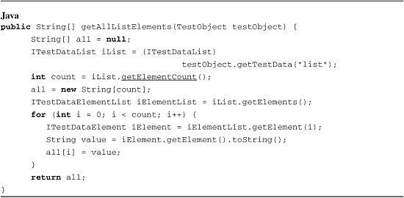

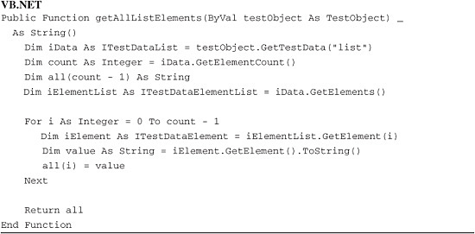

Getting selected elements from a list

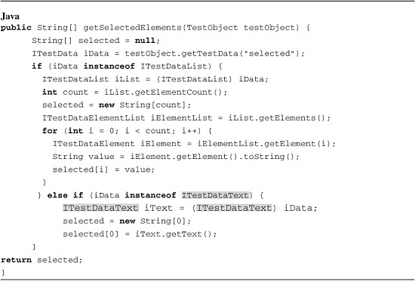

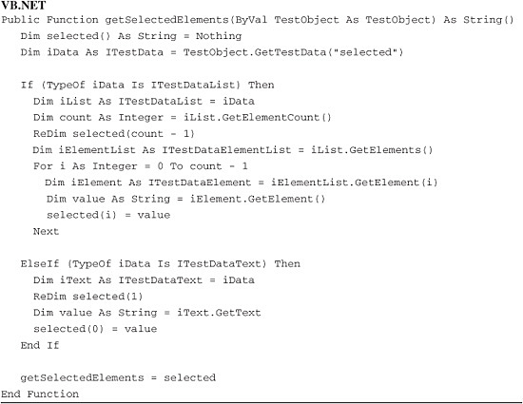

The last two script examples in [Listing 3.9](https://www.safaribooksonline.com/library/view/software-test-engineering/9780137036455/ch03.html#ch03ex09) illustrate a technique for handling the special case of getTestData() returning ITestDataText and not ITestDataList.

**Using getTestData() to Read Data in a Table**

As opposed to lists, which require several method calls (and three interfaces) to get list values, tabular table is straightforward; you use only one interface. The initial learning challenge is the test data type arguments. There are quite a few; some are test object domain-specific. (See [Tables 3.3](https://www.safaribooksonline.com/library/view/software-test-engineering/9780137036455/ch03.html#ch03tab03), [3.4](https://www.safaribooksonline.com/library/view/software-test-engineering/9780137036455/ch03.html#ch03tab04), and [3.5](https://www.safaribooksonline.com/library/view/software-test-engineering/9780137036455/ch03.html#ch03tab05).)

**Table 3.3** HTML Tables

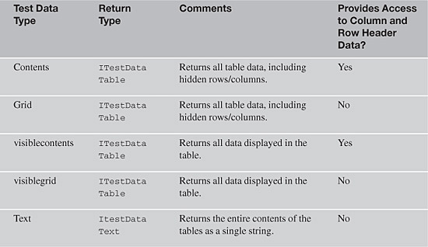

**Table 3.4** Swing Tables

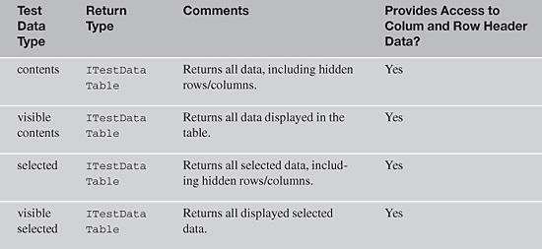

**Table 3.5** Microsoft .NET Grids

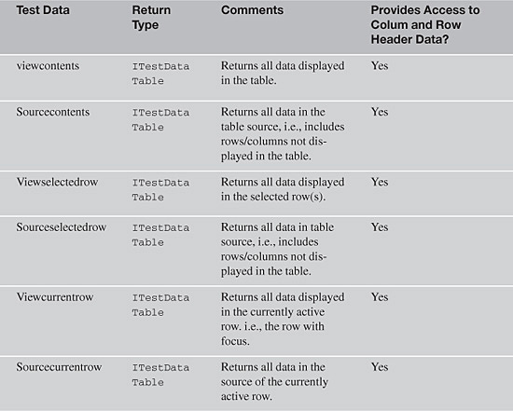

[Table 3.6](https://www.safaribooksonline.com/library/view/software-test-engineering/9780137036455/ch03.html#ch03tab06) lists the most commonly used methods in ITestDataTable.

**Table 3.6** Most Commonly Used ITestDataTable Methods

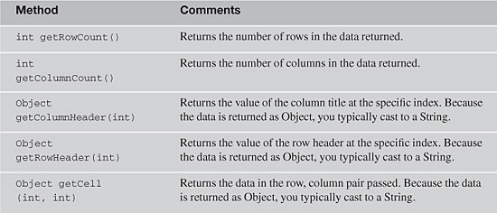

[Listing 3.10](https://www.safaribooksonline.com/library/view/software-test-engineering/9780137036455/ch03.html#ch03ex10) provides two examples that print to the console (Output window in Visual Studio) all the test data types available in the (table) test object passed. This method (function in VB.NET) can be used at design time to compare what is returned in each case and to help you determine the appropriate test data type argument for a table you are coding against.

**Listing 3.10** Printing all of a table’s test data types

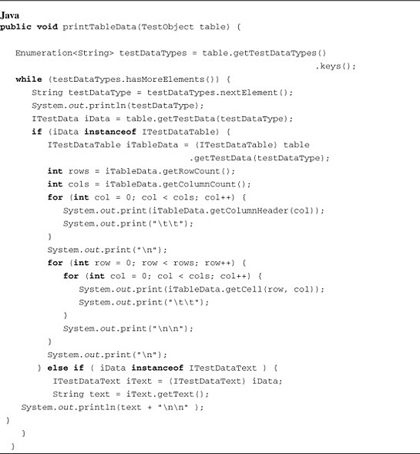

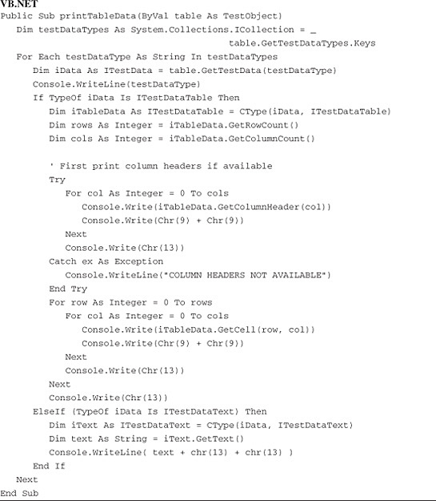

Referring to the previous code samples, note the following. First, you want to note that the target (control) of the code is a Swing table. To get all test data types applicable to the table, you call getTestDataTypes. The ITestDataTable object (returned by the call to getTestData()) can be used to determine the number of rows and columns in the table by calling getRowCount() and getColumnCount(). If column headers are not available, an exception can be thrown; you therefore use a try block to prevent the script from failing. To retrieve the value in any particular cell, call getCell(row, col), passing in the row and column index of the cell you’re interested in (start counting at 0). getCell() returns the value as an object, which you almost always downcast to a string. In Swing tables, the column and row headers are separate Swing objects from the table object. The data in these headers, however, can be retrieved via methods in the ITestDataTable object returned by calling getTestData() on the table. In other words, your scripts do not need to worry about having (or getting) separate column or row header TestObjects. After you have the ITestDataTable in the table, call getColumnHeader() and getRowHeader() methods, respectively.

**Using getTestData() to Extract Data from a Tree**

From a test data type perspective, trees are simple. There are only two test data types: tree and selected.

**Table 3.7** Tree Object Data Types

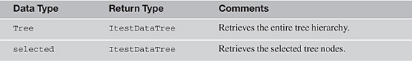

**Tree Talk**

There’s a special vocabulary used with trees with which you might not be familiar. A tree consists of elements referred to as *nodes*. Each node can have a parent, siblings, and children. A node that has no parent is called a *root node*. A tree can have one root node (the Classics music tree) or multiple root nodes (the tree in the Rational Functional Tester Preferences dialog box). A node that has no children is called a *leaf* or *terminal node.*

In the Classics music tree, Composers is the root node. Composers has no siblings. Its children are Schubert, Haydn, Bach, Beethoven, and Mozart. Mozart has three children. Symphony No. 34 has no children and is therefore a leaf node.

Before continuing, you need to clarify what is returned with respect to *selected* tree nodes. If you click Bach’s Violin Concertos in Classics, it is the selected node. You might think that in this scenario if you get selected data from the tree, just Violin Concertos will be returned. This is not the case. To see what getTestData() returns, insert a Data verification point on the tree with Bach’s Violin Concertos selected and select **Selected tree hierarchy**. You see something similar to what is displayed in [Figure 3.22](https://www.safaribooksonline.com/library/view/software-test-engineering/9780137036455/ch03.html#ch03fig22).

**Figure 3.22** Data verification point—Selected tree hierarchy (single node selected)

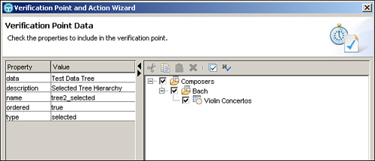

Notice that Rational Functional Tester captures the selected element along with its ancestor nodes all the way up to the root node. If multiple nodes are selected (hold down the Ctrl key and select Symphony No. 9 and Mozart’s Symphony in C, No. 41: Jupiter), the selected tree hierarchy would look like [Figure 3.23](https://www.safaribooksonline.com/library/view/software-test-engineering/9780137036455/ch03.html#ch03fig23).

**Figure 3.23** Data verification point—Selected tree hierarchy (multiple nodes selected)

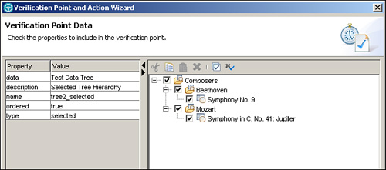

[Table 3.8](https://www.safaribooksonline.com/library/view/software-test-engineering/9780137036455/ch03.html#ch03tab08) lists the interfaces for accessing tree data and the commonly used methods in each interface.

**Table 3.8** Interfaces and Their Methods Used for Accessing Trees

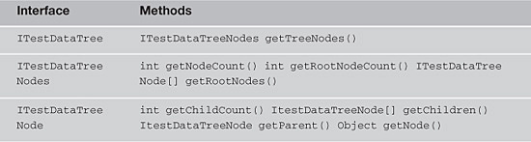

The following steps can be used as a generic template for acquiring the root nodes of a tree control.

**1.** Call the tree control’s getTestData() method. The data will be returned as an ITestDataTree interface.

**2.** On the ITestDataTree reference, call getTreeNodes(). This returns the data as an ITestDataTreeNodes interface.

Note that if you want to get to the selected leaf nodes in the tree, you need to start at the top of the tree and traverse down to them (such as using some sort of loop). To get to the top of a tree, call getRootNodes(), which returns an array of individual ITestDataTreeNodes. It returns an array because depending on the tree, there can be more than one root node.

Also note that after you have the data contained in an ITestDataTreeNodes interface, you can find out how many nodes are in the data returned by calling getNodeCount(). It’s important to note that getNodeCount() doesn’t necessarily return the number of nodes in the test object; it returns the number of nodes in the data returned by the initial call to getTestData(). If you pass getTestData() an argument of tree, it returns the total number of nodes in the tree (for example, the Composer tree in Classics returns 20 nodes). If you pass an argument of selected, it returns the number of nodes in the selected tree hierarchy. If Bach Violin Concertos is selected, it returns three (because the nodes returned are **Composers** > **Bach** > **Violin Concertos**).

**3.** As listed in [Table 3.8](https://www.safaribooksonline.com/library/view/software-test-engineering/9780137036455/ch03.html#ch03tab08), there are three key methods you can invoke on an ITestDataTreeNode. getNode() returns the node data as an Object. Thus, if you call getNode() on the first (and only) root node and cast that to a string, you can print it out (or more likely store it in a variable for further processing).

[Listing 3.11](https://www.safaribooksonline.com/library/view/software-test-engineering/9780137036455/ch03.html#ch03ex11) provides two examples—one Java and one VB.NET—that exemplify the previous template steps.

**Listing 3.11** Printing a tree’s root nodes

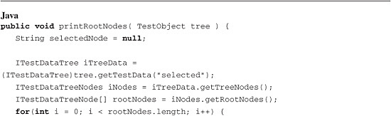

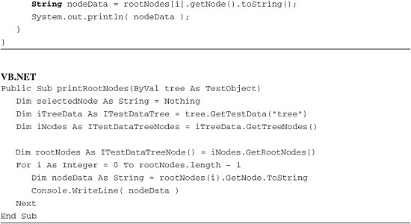

The next code sample in [Listing 3.12](https://www.safaribooksonline.com/library/view/software-test-engineering/9780137036455/ch03.html#ch03ex12) builds off the prior steps. In particular, after you acquire the root node as an ITestDataTreeNode, you can start traversing it. To descend one level, call getChildren(). This returns the ITestDataTreeNode’s children (in the returned data, not the test object) as an array of ITestDataTreeNodes. Note that the data type of the root nodes is the same as any other node in a tree, namely ITestDataTreeNode. After you have the array of child ITestDataTreeNodes, you can acquire their data, using the getNode() method and casting it to a string—similar to what was accomplished in [Listing 3.11](https://www.safaribooksonline.com/library/view/software-test-engineering/9780137036455/ch03.html#ch03ex11).

**Listing 3.12** Get the text of the selected node in a tree

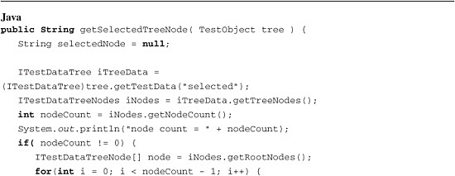

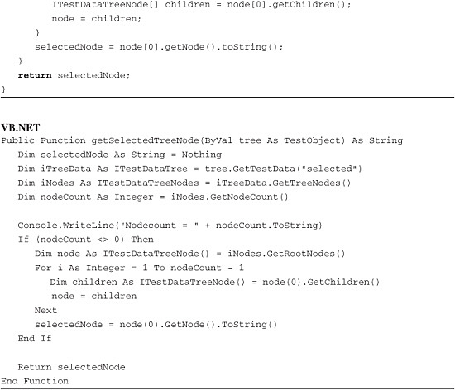

**Obtaining Data from a Test Object That the Rational Functional Tester Verification Point Wizard Does Not Capture**

This large topic is discussed here and explored in more detail in other sections. Several techniques are used to deal with this challenge, the simplest of which from a coding perspective is to try to get the data into the Clipboard. If this can *reliably* be done, you can get the data into a script variable (though this technique might not be your first choice).

As discussed in the “[Working with the Clipboard Object](https://www.safaribooksonline.com/library/view/software-test-engineering/9780137036455/ch03.html#ch03sec1lev6)” section in this chapter, Rational Functional Tester gives you access to the system Clipboard. This provides access to the two methods used for manipulating the Clipboard: setText() and getText(). These enable you to work with test objects that Rational Functional Tester has difficulty extracting data from.

The following reference example is an open document in Microsoft Word. If you point the Rational Functional Tester Verification Point Wizard at a Microsoft Word document, it does not see the contents of the document. You can, however, get the data into a variable in your script by using the keyboard and a little code.

First, you click the document to place keyboard focus on it. Then you use the keyboard to put the data into the Clipboard (versus trying to manipulate the Word menu). The Rational Functional Tester API has two methods to work with the keyboard: inputChars() and inputKeys(). Both take string arguments, but there’s a key difference between them: inputChars() treats every character it has passed literally, and inputKeys() assigns special meaning to certain characters, as shown in [Table 3.9](https://www.safaribooksonline.com/library/view/software-test-engineering/9780137036455/ch03.html#ch03tab09).

**Table 3.9** Characters with Special Meanings in Scripts

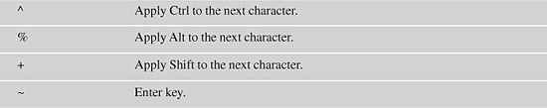

Passing inputKeys ^a^c causes Rational Functional Tester to press Ctrl+A (select all) and then Ctrl+C (copy), copying the contents of the entire document to the Clipboard. After the data is copied to the Clipboard, you are home free. To get the data in the Clipboard, you call getSystemClipboard().getText(). This is detailed in [Listing 3.13](https://www.safaribooksonline.com/library/view/software-test-engineering/9780137036455/ch03.html#ch03ex13).

**Listing 3.13** Using the Clipboard to get data from a test object

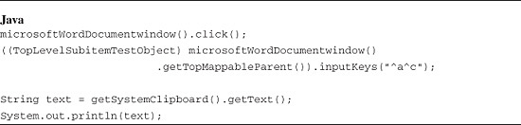

**Creating a Custom Verification Point**

In addition to the flexibility of being able to use datapool references in verification points created with the Rational Functional Tester Verification Point Wizard, you can create your own dynamic verification points in code. RationalTestScript (the root of all script classes) has a method, vpManual(), which you can use to create verification points.

vpManual() is used when you want your script to do all the work of verifying data. That work consists of capturing expected data, capturing actual data, comparing actual data with expected data, and logging the results of the comparison. Think of *manual* as referring to manual coding.

This discussion begins with the first signature (which you will likely use most often). In vpManual’s three-argument version, you supply a name for your verification point along with the baseline and actual data associated with the verification point. vpManual() then creates and returns a reference to an object; specifically, one that implements Rational Functional Tester’s IFtVerificationPoint interface. The verification point metadata (name, expected, and actual data) are stored in the returned IFtVerificationPoint.

image

There are a couple of items to note about using vpManual():

• **vpName—**The verification point name must be a script-unique valid Java (or .net) method name and be less than 30 (.net) or 75 (Java) characters.

• **Baseline and Actual data—**The compiler accepts a reference to anything that inherits from Object (which means that in .NET, any argument you pass is acceptable; Java allows anything other than primitives, such as int, bool, and so on); however, you need to satisfy more than the compiler. To automate the comparison of baseline with actual data, you need to pass data types that Rational Functional Tester knows how to compare (you don’t want to have to build your own compare method). This limits you to passing value classes. Some examples of legal value classes are: any data returned by getTestData(), strings, primitives, wrapper classes (Integer, Boolean, and so on), common classes that consist of value class fields (for example, Background, Color, Bounds, ITestData, meaning, anything returned by getTestData()), and arrays (one and two-dimensional), vectors, and hashtables that contain value class elements.

What do you do with the IFtVerificationPoint that vpManual() returns? In the simplest case, you call performTest() and get on with things. performTest() compares the baseline with the actual and logs the results (boolean) of the comparison. See [Listing 3.14](https://www.safaribooksonline.com/library/view/software-test-engineering/9780137036455/ch03.html#ch03ex14).

**Listing 3.14** A simple comparison

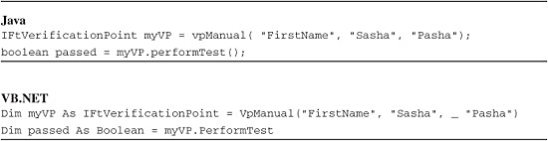

In two lines of code, you have done quite a bit. You created a verification point and compared and logged the results of comparing the baseline to the actual data. It’s common to combine these two statements into one:

vpManual( "FirstName", "Minsk", "Pinsk").performTest();

You use this style when the only method you need to invoke on the IFtVerificationPoint returned by vpManual() is performTest().

It’s important to note that the three-argument version of vpManual() does not persist baseline data to the file system for future runs. It’s also important to stress the importance of the uniqueness of the name in the script.

To illustrate how Rational Functional Tester behaves when a verification point is not unique, consider the simple example where vpManual is called in a loop (demonstrated in [Listing 3.15](https://www.safaribooksonline.com/library/view/software-test-engineering/9780137036455/ch03.html#ch03ex15)). The loop in each code sample simply compares two numbers. To introduce some variety, you force the actual value to equal the baseline value only when the baseline value is even.

**Listing 3.15** Consequences of a nonunique verification point name

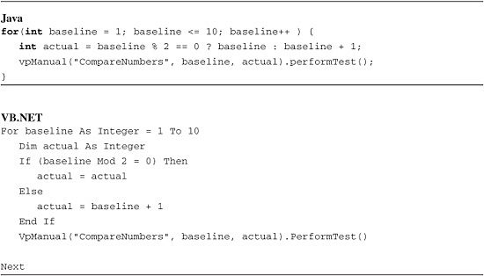

If you execute this code, you see two interesting results in the log:

• The pass/fail status for each verification point is what’s expected (half pass, half fail).

• The comparator shows the correct actual values for each verification point, but a baseline value of 1 for every verification point. The reason for this is that after an IFtVerificationPoint has been created, the baseline cannot be updated.

The common technique to deal with this issue (in a looping context) is to append a counter to the verification point name, guaranteeing a unique name per iteration. This is shown in [Listing 3.16](https://www.safaribooksonline.com/library/view/software-test-engineering/9780137036455/ch03.html#ch03ex16).

**Listing 3.16** Guaranteeing a unique verification point name

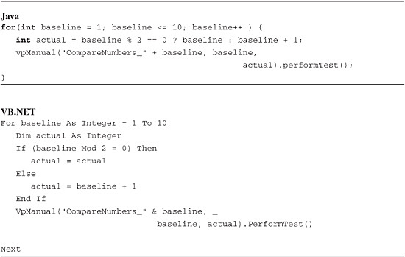

**Persisting Baseline Data**

In addition to the three-argument version of vpManual(), there is a two-argument version of vpManual():

IFtVerificationPoint vpManual( String vpName, Object data )

The two-argument version is used when you want to persist the baseline data to the Rational Functional Tester project. Here’s how it works. The first time performTest() is called on an IFtVerificationPoint with a given name (the name passed to vpManual()), no comparison is done. The baseline data is written to the RFT project and a verification point displays in the Script Explorer (and an informational message is written to the log). With each *subsequent* execution of performTest() on an IFtVerificationPoint with the same name, the data argument passed to vpManual() is treated as actual data, and performTest() executes the comparison, logging the result.

**Changing the Value of a Test Object’s Property**

Properties cannot only be read using getProperty(), but they can be changed using setProperty():

public void setProperty( String propertyName, Object propertyValue )

Although you most likely will not use setProperty() nearly as often as you use getProperty(), it is a method worth knowing about. SetProperty() takes two arguments: the property to change and the value to change the property to.

The reference example is one that involves setting data field values in test objects (for example, text fields). In general, you should use inputKeys() or inputChars() to enter data into the SUT. With some cases, however, this becomes challenging. One such context is internationalization testing. inputKeys() and inputChars() can enter characters only in the current keyboard’s character set. If the current keyboard is set to English, for example, RFT throws a StringNotInCodePageException if your script attempts to enter any nonEnglish characters.

One potentially viable solution is to use setProperty() instead of inputKeys() to set the field value. The first step is to determine the property you need to set. Manually set a value, and then examine the test object using either the Inspector or the Verification Point and Action Wizard. Search for a property whose value is the data value you entered. If you enter a search term of Pasta Norma in a Google search field and examine the field with the Inspector, you see two properties whose values are Pasta Norma: value and .value. This is not uncommon: It’s possible that the data value is represented by more than one property. It’s a good idea to note all these property names because some might be read-only. If you try to set a property value that’s read-only, Rational Functional Tester throws an exception.

If you had a datapool with different search strings in different character sets, you can manipulate the scripts to perform multiple searches, as shown in [Listing 3.17](https://www.safaribooksonline.com/library/view/software-test-engineering/9780137036455/ch03.html#ch03ex17).

**Listing 3.17** Using SetProperty() to set data in a test object

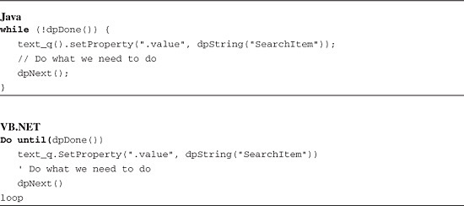

**Why Is InputKeys() Preferred?**

To illustrate why inputKeys() is the preferred method to enter data into objects, test what happens if you set the quantity of CDs to buy in the Classics sample application:

quantityText().setProperty("Text", "4");

You see something odd happen (or, *not happen* in this case): The total amount is not updated to reflect the new value. The reason for this is that the total amount is updated when the inputKeys event is fired. setProperty() does not cause this event to fire and is therefore not a possible technique to set the quantity field.

**Evolving Custom Scripting into Reusable Methods**

Up to this point, you have learned how to make different types of enhancements to your scripts, making them more robust. You saw how to add delays, introduce timers, work with the Windows Clipboard, manipulate different objects you recorded (such as test objects and verification points), and so on. Rational Functional Tester enables you to expand these techniques by turning them into generic, reusable methods.

Methods that are reusable and, ideally generic, enable you to apply them to more than one object or script. You can often use them across your entire test project. This enables you to create methods that benefit everybody on your team, saving time on your overall test automation effort.

The first thing that is involved with creating custom methods is setting up the signature. Basically, you specify the type of data your method needs to receive and the type of data it needs to send back when it’s done executing. You can work with the typical data types and objects that the Java and VB.NET languages work with. For example, you might have an add method with a signature that looks like the following:

public int add(int i, int j)

The VB.NET equivalent is:

Public Function add(ByVal i As Integer, ByVal j As Integer) As Integer

In both instances, you are merely passing two integers into the method (function in VB.NET), returning the sum of them as an integer.

Rational Functional Tester enables you to pass and return test objects. This gives you the ability to create custom methods for the objects that you capture in your test object map. A simple instance of this might be a method to test if an object is enabled or not. The method signature would like the following Java example:

public Boolean isEnabled(TestObject myGuiObject)

In VB.NET, you see:

Public Function isEnabled(ByVal myGuiObject As TestObject) As Boolean

If you use a signature, such as the preceding examples, you can pass any test object that contains enabled property to your custom method. You can test if a button is enabled before you click it, a tree is enabled before you navigate it, a text box is enabled before typing in it, and so on.

After you have the signature defined for your method, it is a matter of providing the code that accomplishes your desired task. You might write reusable methods that wait for test object properties to change, that acquire data from test objects, and set properties for test objects. Regardless of the methods that you create, you can organize and package them into *Helper Superclasses*, calling them from your scripts.

Helper Superclasses (also called Helper Base Classes in the VB.NET version of the tool) are an excellent way for you to create a simple, project-wide means for storing your reusable methods. You can easily create a Helper Superclass in Rational Functional Tester by performing the following steps:

**1.** Click **File > New > Helper Superclass** (this launches the Create Script Helper Superclass Wizard).

**2.** Select the location to store your Helper Superclass.

**3.** Provide a name for your Helper Superclass.

**4.** Click the **Finish** button.

If you are using the VB.NET version, the steps are:

**1.** Click **File > New > Add Helper Base Class** (this will launch the Add New Item Wizard, preselecting the Script Helper Base Class template).

**2.** Provide a name for your Helper Base Class.

**3.** Provide a location for your Helper Base Class.

**4.** Click the **Add** button.

In either case, you end up with an empty class, prebuilt to extend the default capabilities of Rational Functional Tester’s **RationalTestScript** class. This is where you start constructing your custom, reusable methods. The following code samples, contained in [Listing 3.18](https://www.safaribooksonline.com/library/view/software-test-engineering/9780137036455/ch03.html#ch03ex18), show a Java and a .NET helper class. These contain the following sample methods from prior sections:

• printValueProperties()—“Retrieving All Properties of a Test Object” section

• getAllListElements()—“Using getTestData to Extract Data from a List” section

• printRootNodes()—“Using getTestData to Extract Data from a Tree” section

**Listing 3.18** Helper Classes

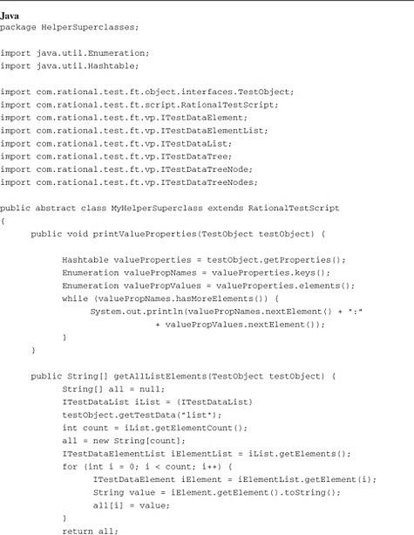

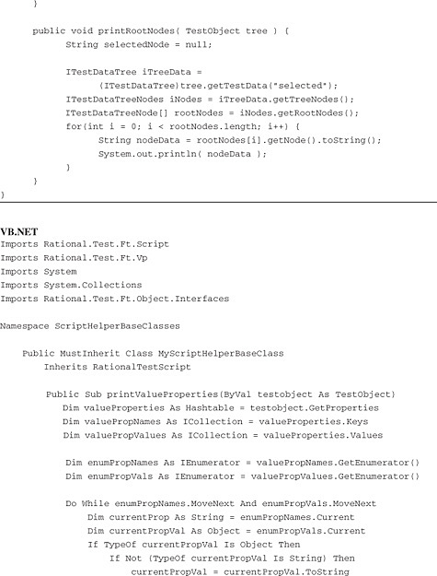

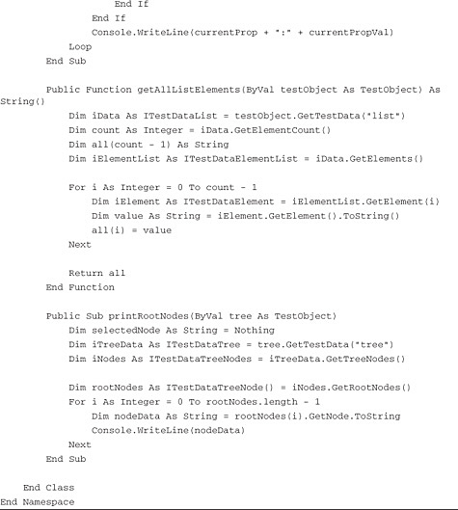

Please note that you might need to import certain packages and namespaces (depending on whether you are using Java or VB.NET). You receive errors from the compiler that let you know that certain classes, structures, objects, and so on do not exist. In the Java version of the tool, you can usually perform a **<Ctrl> + O** keystroke combination. This imports the necessary packages. There might be instances where you have to review the error messages to get an idea of what package needs to be imported. The VB.NET version of the tool requires you to import the necessary namespace.

After you have your Helper Superclass set up, creating the desired reusable methods, you need to perform two more steps. The first is to tell your test scripts to use the new class. In other words, you want to tell your scripts about the new methods that you created. The second step is to actually call your custom methods from your script.

You can associate your new Helper Superclass either at the individual script level or at the project level. Associating your Helper Superclass at the project level causes any new script to be aware of your custom methods. If you already have scripts created, you need to associate your Helper Superclass to each of them. To associate your Superclass to your project, you do the following:

**1.** Right-click your project node in the Functional Test Projects view (Solution Explorer, if you’re using Rational Functional .NET).

**2.** Click **Properties**.

**3.** Click **Functional Test Project** (on the left-hand side of the Properties window).

**4.** Click the **Browse** button next to the Script Helper Superclass property (Script Helper Base Class property if you are using Rational Functional Tester .NET).

**5.** Select your created Helper Superclass (Helper Base Class).

Note: You might need to type the first few letters of the name of your Super Helper class to get it to display in the list when using the Java version of Rational Functional Tester.

**6.** Click the **OK** button.

Associating your Helper Superclass to individual scripts is a similar process. You need only to perform the following steps:

**1.** Right-click an existing script in your project node in the Functional Test Projects view (Solution Explorer, if you are using Rational Functional .NET).

**2.** Click **Properties**.

**3.** Click **Functional Test Script** (on the left-hand side of the “Properties” window).

**4.** Click the **Browse** button next to the Helper Superclass property.

**5.** Click the created Helper Superclass (Helper Base Class).

Note: You might need to type the first few letters of the name of your Super Helper class to get it to appear in the list when using the Java version of Rational Functional Tester.

**6.** Click the **OK** button.

After you make the necessary Helper Superclass associations, the last thing you need to do is to actually use the custom work that you created. Referring to the methods and functions in [Listings 3.17](https://www.safaribooksonline.com/library/view/software-test-engineering/9780137036455/ch03.html#ch03ex17) and [3.18](https://www.safaribooksonline.com/library/view/software-test-engineering/9780137036455/ch03.html#ch03ex18), you simply need to call the specific custom method(s) that you need.

[Figures 3.24](https://www.safaribooksonline.com/library/view/software-test-engineering/9780137036455/ch03.html#ch03fig24) and [3.25](https://www.safaribooksonline.com/library/view/software-test-engineering/9780137036455/ch03.html#ch03fig25) show scripts that make calls to the custom methods contained in the Helper Superclass. This should give you an idea of how your custom work can save time for the other members on your team. They do not have to reinvent the wheel you already created. They can simply reuse the code that you built and use the method(s) that you placed in a Helper Superclass.

**Figure 3.24** Calling custom methods in Helper Superclass—Java

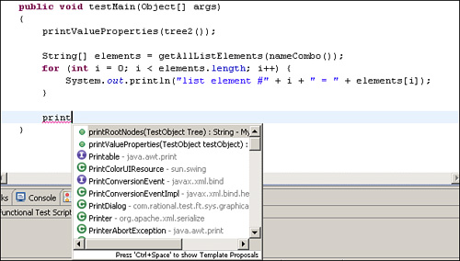

**Figure 3.25** Calling custom functions in Helper Base Class—VB.NET

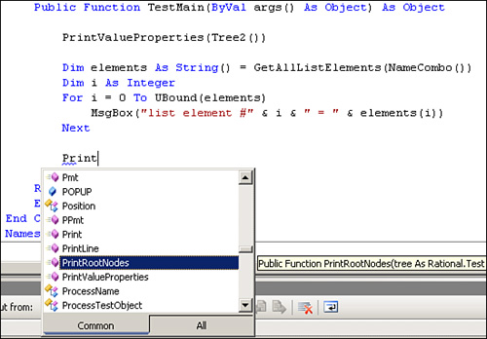

**Summary**

This chapter provides you with the knowledge necessary to expand your skill set outside of the realm of record and playback test automation. You should now have the knowledge necessary to handle such tasks as synchronizing your script playback with any latency issues your application might face, acquiring data from the Windows Clipboard, manipulating data in test objects, and so on. Further, you should now possess the ability to turn your custom scripting into methods that can be reused across your project.

You should also note that this chapter provides some building blocks for more advanced code-oriented testing. The ability to create reusable methods is a commonplace task for many scripting activities you might find yourself performing in Rational Functional Tester. Further, you might find that creating custom verification points is more valuable, at times, than using the built-in ones. In any case, you should now have the level of comfort to move onto more advanced scripting tasks.

[Prev](https://www.safaribooksonline.com/library/view/software-test-engineering/9780137036455/ch02.html)

[Chapter 2. Storyboard Testing](https://www.safaribooksonline.com/library/view/software-test-engineering/9780137036455/ch02.html)

[Next](https://www.safaribooksonline.com/library/view/software-test-engineering/9780137036455/ch04.html)

[Chapter 4. XML and Rational Functional Tester](https://www.safaribooksonline.com/library/view/software-test-engineering/9780137036455/ch04.html)

**Welcome to Safari**. Remember, your free trial will end on March 7, 2015, but you can [subscribe at any time](https://www.safaribooksonline.com/subscribe/)

* [Recommended](https://www.safaribooksonline.com/r/)
* [Queue](https://www.safaribooksonline.com/s/)
* [Recent](https://www.safaribooksonline.com/recent/)
* [Topics](https://www.safaribooksonline.com/t/)
* [Settings](https://www.safaribooksonline.com/u/)
* [Blog](http://blog.safaribooksonline.com/)
* [Support](http://support.safaribooksonline.com/?prod=flow)
* [Support](http://msupport.safaribooksonline.com/?prod=flow)
* [Feedback](mailto:feedback@safaribooksonline.com)
* [Sign Out](https://www.safaribooksonline.com/accounts/logout/)

© 2015 [Safari](http://www.safaribooksonline.com/).   
[Terms of Service](https://www.safaribooksonline.com/terms/) / [Membership Agreement](https://www.safaribooksonline.com/membership-agreement/) / [Privacy Policy](https://www.safaribooksonline.com/privacy/)

[**Make font larger Make font smaller**](https://www.safaribooksonline.com/library/view/software-test-engineering/9780137036455/ch03.html)